Lab 1: First Web API using .NET Core
Hands-on in this document

Objective
- To understand the concepts of RESTful Web Services, Web API, and Microservices.
- To understand HTTP Request and HTTP Response.
- To learn HTTP Action Verbs and HTTP Status Codes.
- To create and execute a simple ASP.NET Core Web API application.
- To create a controller with Read and Write actions.
Procedure
Create a New Web API Project
- Open Visual Studio 2022.
- Click Create a new project.
- Select ASP.NET Core Web API.
- Click Next.
- Enter the project name as FirstWebAPI.
- Choose the project location.
- Click Next.
- Select the required .NET framework.
- Keep Authentication as None.
- Click Create.
Result:
A new ASP.NET Core Web API project was created successfully.
Examine the Project Structure
The project contains the following important files and folders:
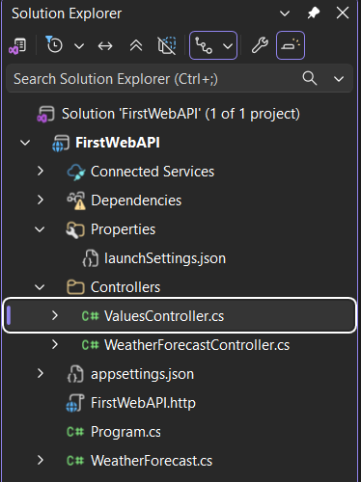
Run the Application
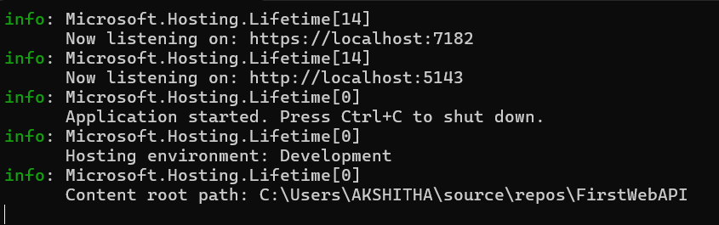Observation:
The application started successfully without any errors.
Execute the GET Action Method
The following URL was opened in the browser:
https://localhost:7182/weatherforecast
The application returned the following JSON response:
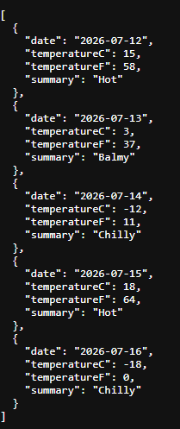
Observation:
The GET request executed successfully and returned weather forecast data in JSON format.
Create a Read/Write Controller
To create a controller with Read and Write actions:
- Right-click the Controllers folder.
- Select Add → Controller.
- Choose API Controller with read/write actions.
- Click Add.
- Enter the controller name as ValuesController.
- Click Add.
Visual Studio automatically generated the following action methods:
- GET
- GET by ID
- POST
- PUT
- DELETE
These methods demonstrate the standard HTTP Action Verbs used in Web APIs.

Verify the Generated Controller
The generated ValuesController contains the following action methods:
- GET – Retrieves data.
- GET(id) – Retrieves a specific record.
- POST – Adds new data.
- PUT – Updates existing data.
- DELETE – Deletes existing data.
https://localhost:7182/api/values
